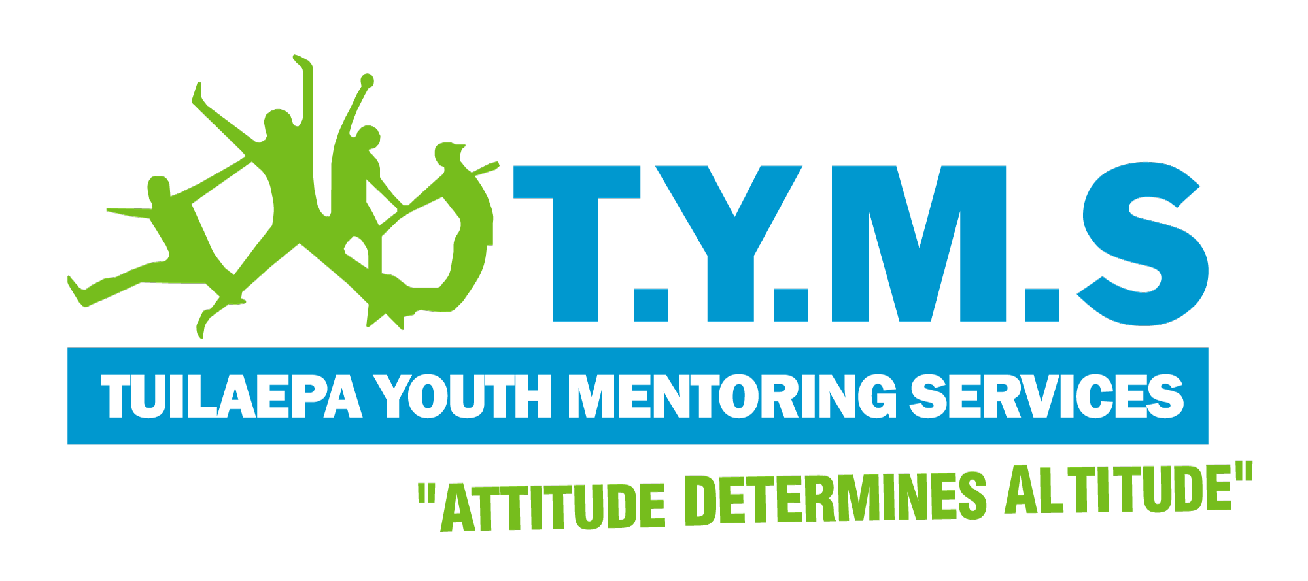
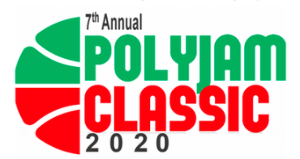
Polyjam Classic 2020
Full-day Pacific Basketball Competition

Saturday 5th December 2020 | Birdwood Park, Ranui

REGISTRATION FORM (FOR UNDER 14’S LEAGUE)

Welcome to the Polyjam Classic Under 14’s league.
Please note that this league will be run as 3v3 Basketball, on the Birdwood half-court. As a children's league, this round is entirely FREE and does not require a fundraiser player fee.
We do ask however that each team has an assigned guardian in charge, present on the day.

Team Name:

No. | Name (Singlet Size) | Guardian Name | Guardian’s Number
1
2
3

Team Captain Name:

Guardian in Charge: Mobile:

Please state if any of your minors have any medical/health conditions e.g. asthma

_________________________________________________________________________

I acknowledge that I am responsible for the actions and behaviour of my team, and that I will take care and be accountable for the return of all TYMS singlets at the end of the tournament.

Signature: Date:

